Rash Identification
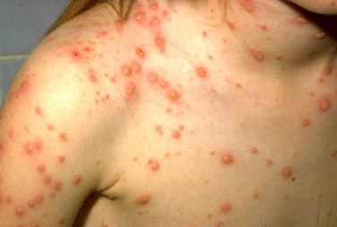
Chickenpox
Incubation period 14-16 days
Mild prodrome for 1-2 days
Lesions appear first on head; most concentrated on trunk.
Vaccination required at 12 months and 4 years.
Exclusion from school until all lesions are scabbed.

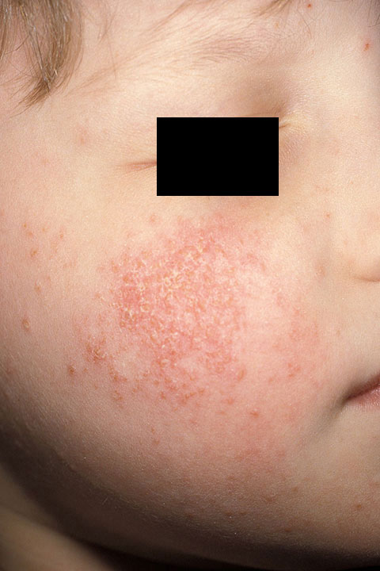
Contact Dermatitis
Red rash that appears 24-72 hours after contact with the allergen.
Blisters or welts may form in a pattern on exposed areas.
Rash itches.
No exclusion.
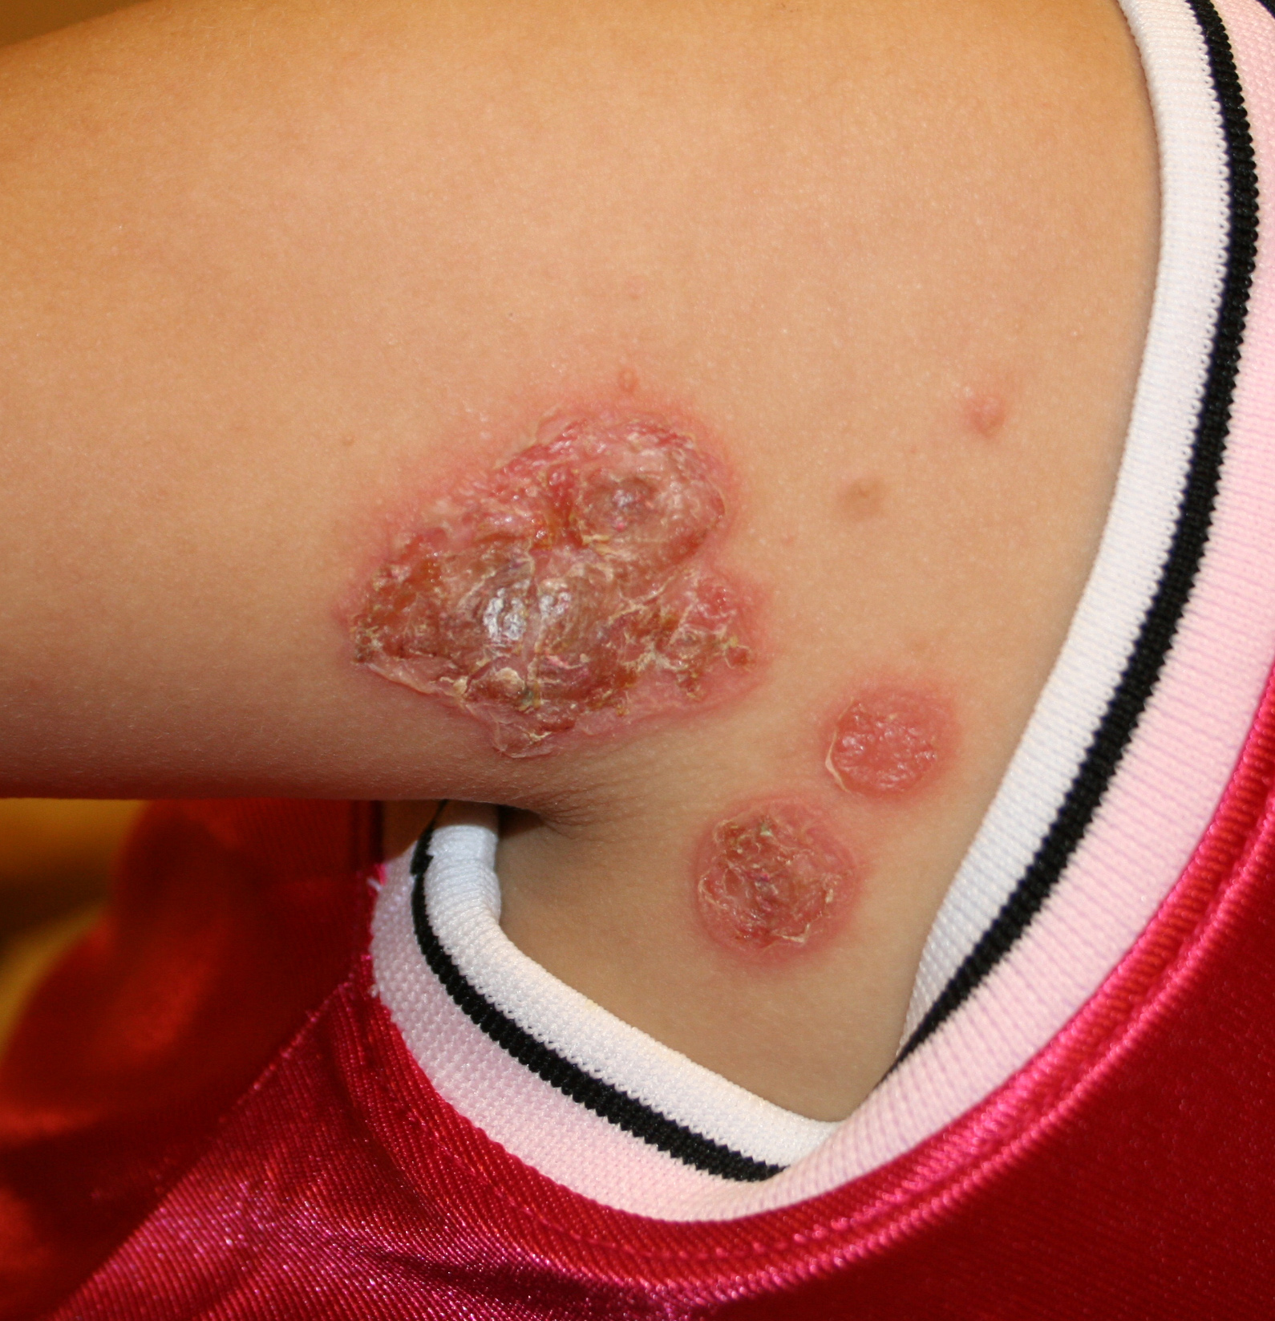
Impetigo
Bacterial infection
Spread by direct contact with lesions or with nasal carriers.
One or multiple pimple-like lesions surrounded by reddened skin.
Lesions fill with pus, then break down over 4-6 days and form a thick crust.
Exclusion until treatment has begun.
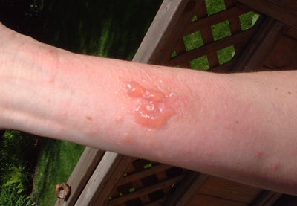
Poison Ivy
Red Rash.
Extreme itching.
Rash includes red bumps and may also form large weeping blisters.
Rash erupts in streaks or patches where the plant touched the skin.
No exclusion

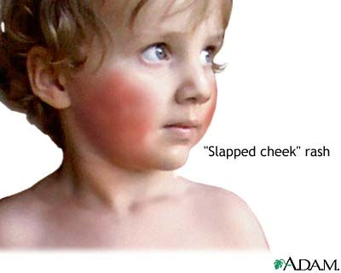
Fifth Disease:
Acute viral disease.
Low grade fever, headache and mild cold-like symptoms.
Blotchy red rash that begins on face and spreads to the
extremities.
Rash does not ususally appear on palms or soles of feet.
May take 1 to 3 weeks to resolve.
Exculsion only if febrile.

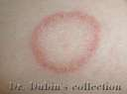
Ringworm
Fungal infection of the skin.
Ringworm appears as oval or ring shaped patches on the body.
Dogs and cats are the main culprits for transmission to humans
Children are more prone to have ringworms than adults.
Exclusion until treatment has begun.

Provided by : Gregg County Health Department/Public Health Preparedness
405 E. Marshall, Longview, TX 75601 Phone: 903-237-2605

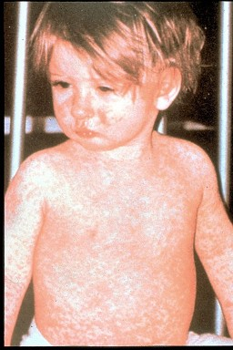
Measles (Rubeola)
Highly contagious viral infection.
Incubation 9-12 days.
S/S: Fever, cough, runny nose, red eyes, spots in mouth, then rash on face that spreads down the body.
Other complications include ear infection and diarrhea.
Vaccination at 12 months and 4 years.
Exclusion for four days after outbreak of rash.

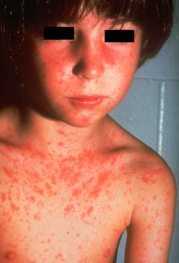
Rubella (aka German & 3day measles)
Primarily affects the skin and lymph nodes.
Droplet transmission from nose and/or throat.
S/S: 1-2 days mild fever, swollen, tender lymph nodes, headache, loss of appetite, mild conjunctivitis, stuffy/runny nose, pain and swelling in joints or no S/S at all.
Pink or light red rash begins on face and spreads downward.
Rash may itch, lasts up to 3 days. As rash clears the skin sheds.
Vaccination required at 12 months and 4 years.
Exclusion for seven days after onset of rash.

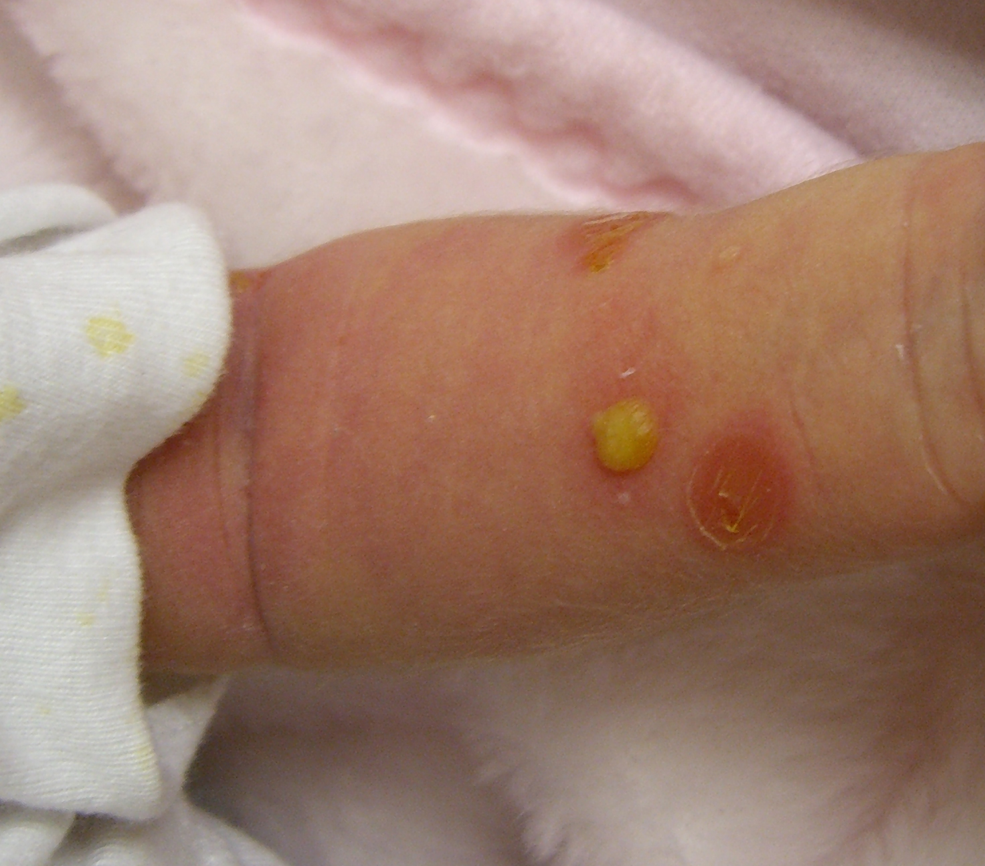

Staph is a bacterial infection.
Spread through the air, contaminated surfaces, and person to person.
Transferred from one area of the body to another on dirty hands and under dirty fingernails.
Can pass from person to person the same way.
Hand washing is the most important way to prevent
staph infections. No exclusion, lesion must be covered at all times.

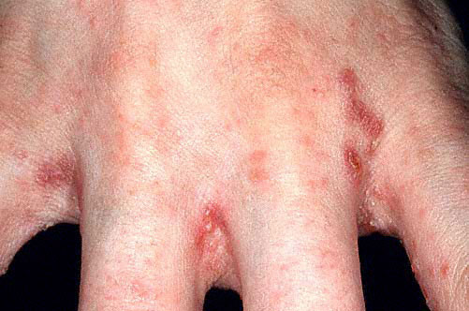
Scabies
Caused by a mite.
S/S: 1-3 mm red papules and vesicles with burrows, extremely itchy.
Black dot at one end of the burrow represents presence of a mite.
Most common areas are webbed spaces (fingers, flexor surfaces of the wrists, elbows, axillae, belt line and feet.
Exclude until after treatment has begun.

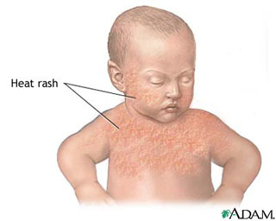
Heat rash is a skin irritation caused by excessive sweating during hot, humid weather. It can occur at any age but is most common in young children.
Heat rash looks like a red cluster of pimples or small blisters. Most likely to occur on the neck and upper chest, in the groin, under the breasts, and in elbow creases
No exclusion

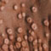
Smallpox
S/S: fever, malaise, headache, severe fatigue, and back ache.
red spots begin in mouth, spread to face, extremities, palms & feet.
Spots progress to small blisters filled with clear fluid.
Lesions on any given area will all be at the same stage.
Lesions are hard, similar to a b-b under the skin.
Lesions have indention in centers.
Vaccination available only during outbreak.
Isolation/quarantine---Since smallpox has been eradicated all cases would be the result of bioterrorism and an extreme emergency.

